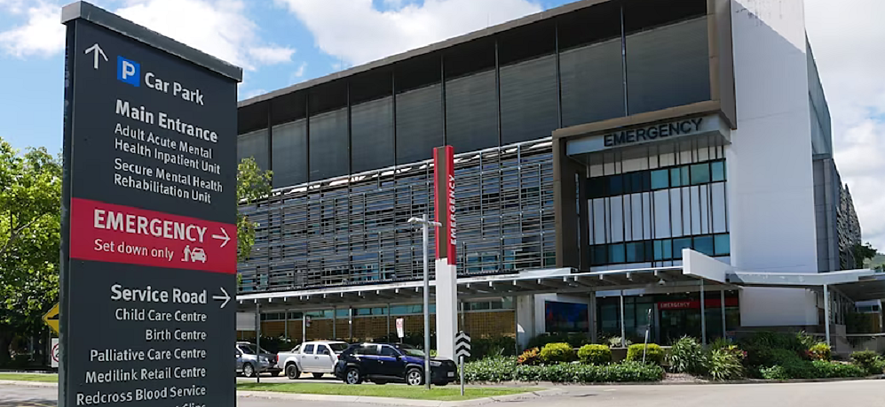

Safeguarding Audiology Practices in Australia.
Independent audiologists are urging all state health ministers to recognise the importance of external regulation of audiology as a profession to safeguard against risks to the public.
Professional body Independent Audiologists Australia welcomed a report released in November 2023 following an investigation of the Townsville University Hospital's Audiology department.
The investigation conducted by the Queensland Government found that Townsville University Hospital incorrectly programmed cochlear implants in some children and misdiagnosed others. The audiology clinic was poorly organised, staff were overworked, and key protocols did not appear to be followed. Read more of the background.
In a media release, an Independent Audiologists Australia (IAA) spokesperson said, “We raise concerns that audits are not routinely performed in all states and recommend that this be considered with urgency.“
“The reviews … highlight the challenges encountered by audiology departments in hospitals: over-scheduling, understaffing, and audiologists often working in isolation.”
IAA recommends that where possible patients should be informed of community-based, private, and not-for-profit cochlear implant and audiology services. Patient choice of service allows an opportunity for second opinions and collegial case management, increasing the standard of care for patients, and reducing economic and social burden for families.
Hub and spoke models of care are utilised successfully across government services and should be implemented in order to preserve and spread State Hospital funding, while increasing convenience and care for families.
Cochlear implant mapping for children and adults is already successfully delivered in private audiological practices and community based not-for-profit centres and is easily accessible with Medicare funding.
“IAA urges all state health ministers to recognise the importance of external regulation of audiology as a profession to safeguard against risks to the public.
“Audiologists in both the public and private sectors provide care to individuals with high care and support needs, including children, the elderly, and those with one or more disabilities.
“Membership of a professional body is voluntary for audiologists in Australia, and there is no requirement to show membership in order to provide hearing services to the public. As such, there is no pathway for permanent disciplinary action should there be a complaint against a non-member.”
“Greater protections to the public via more stringent regulation of hearing health professionals are necessary, for a return of the audiology profession to the realm of ‘health care’.”

Life-long Impact on Children.
If cochlear implants are not properly mapped (programmed and adjusted), it can result in reduced or distorted perception of sounds, including speech sounds, which can negatively impact speech acquisition.
Approximately 40 families of children who experienced the most significant impacts have been offered $50,000 while an additional 57 children recalled for additional testing will be offered $5,000 by the state government.

The Queensland health minister, Shannon Fentiman, said it was time for better regulation of audiologists by the federal government.
“We will be advocating for audiologists to be the next profession registered by the Australian Health Practitioner Regulation Agency.”
Audiology Australia responded.
Audiology Australia also welcomed the release of the report by the Townsville Hospital and Health Service.
“The issues identified in the report parallel those identified in the governance review of the Women and Children’s Health Network (WCHN) in SA in many areas.
Aside from identifying organisational and outcome review issues, the reports highlighted a clear need to look at both the training and qualifications of audiologists providing advanced services, and the systems that support those clinicians to provide high quality care for children.
Audiology Australia supports the recommendations from both reports and hopes to see a quick implementation of all recommendations. As the professional association for audiologists, we are currently reviewing the findings and recommendations in more detail to understand how these may be reflected across our own policies and process to strengthen the audiology profession and protect the community. We look forward to the release of the findings of the pending clinical review of the WCHN in SA. We are also working with our membership and government to support the profession and to provide assistance and advice as reforms are undertaken.
Audiology Australia welcomes any consideration by Government to include audiology as a registered profession and join the 16 health professions currently regulated under the National Registration and Accreditation Scheme (NRAS) and administered by the Australian Health Practitioner Regulation Agency (AHPRA). Whether a health profession joins the NRAS is a collective decision of the State and Territory Health Ministers. We have been actively engaging with government on this issue since 1999 and will continue to do so.
In the meantime, Audiology Australia will continue to strive for the highest standards of self-regulation. Our membership of the National Alliance of Self Regulating Health Professions ensures that our profession must meet equivalent standards to those of AHPRA registered health professionals. All Audiology Australia Accredited Audiologists must maintain high standards of quality control and care and are certified on an annual basis, including recency of practice and continuing professional development. Audiology Australia is also committed to maintaining and expanding credentialling of advanced paediatric practice, recognising that additional skills and expertise are required to provide those services.
All audiologists – whether members of a professional body or not - are subject to the legislative National Code of Conduct for Healthcare Workers. Government also requires audiologists to be accredited by a professional body in order to deliver hearing services such as through the Department of Health’s Hearing Services Program and Medicare.”
Australian College of Audiology said.
“We feel for the children and families affected by this breakdown in the provision of cochlear services within the Queensland and South Australian state healthcare systems.
The priority for these Australians, and those who come into the system after them, is a better multidisciplinary healthcare experience, and improved patient advocacy.
Recognising that there are still ongoing investigations in place, ACAud supports the relevant recommendations for Audiologists included within both recent hospital reviews.
ACAud is committed to contributing to the development of improved clinical pathways for children and adults with cochlear implants. We recognise and endorse the need for specialist training, better support and joined up systems for clinicians working in this area.
Australia has very good public and private hearing care services. It is important that people experiencing hearing difficulties have confidence in their local health services. Anyone with concerns about their treatment or progress should consult their doctor or hearing health practitioner.
All healthcare workers must abide by the National Code of Conduct for Healthcare Workers.
All Audiologists who deliver services under the national Hearing Services Program and Medicare are required to be a member of a professional body.
There are two professional membership bodies for Audiologists in Australia. Our members share a sector-wide Code of Conduct, Scope of Practice and Ethical Review framework. All members work to the National Competency Standards, and must make mandatory declarations annually as to their fitness to practice, formal qualifications, recency of practice and ongoing professional development.
Audiology is one of the smaller medical professions and is self-regulated. National practitioner regulation is a complex and lengthy process involving the agreement of all states and territories. It takes many years to set up and implement. It would provide no immediate effect for the children and adults in the various current state cochlear programs and their families. ACAud’s priority remains supporting improved clinician education, training and multidisciplinary collaboration.”

