SAFE LISTENING WEEK.
Last week of August.

SOCIAL MEDIA POSTS

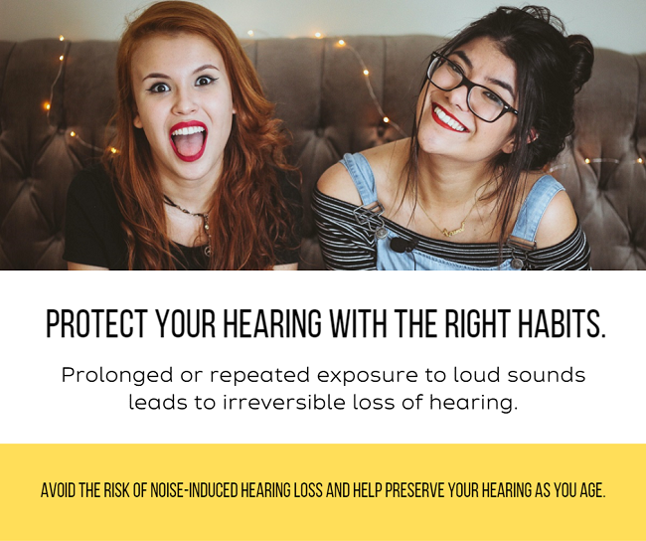

Music at clubs and concerts is often louder than safe limits, and some headphones can play music just as loud. Even a brief exposure to loud sounds can be harmful.

Frequent exposure over time almost certainly leads to tinnitus and hearing loss. The more exposure to loud noise, the worse it gets.

The good news is that hearing loss caused by noise can be avoided and prevented by simple safe listening habits.

- Keep the volume down.

- Limit time spent engaged in noisy activities.

- Wear ear protection.

- Be aware of listening levels.

Love your music but protect your ears.

#safelisteningweek
#safelistening

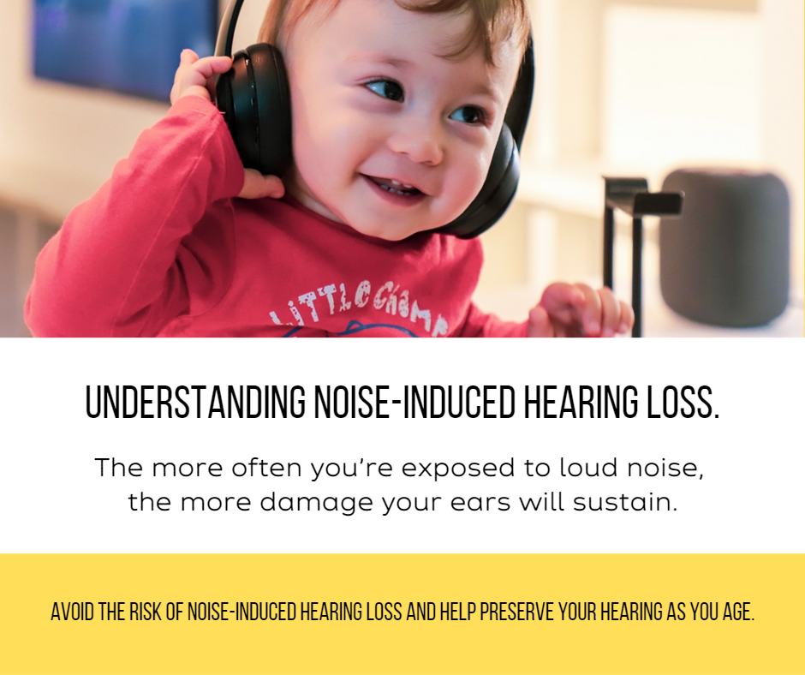

It is important to take care of your hearing to prevent hearing loss and related health problems.

Loud sounds damage ears and can lead to persistent tinnitus and hearing loss. The more exposure to loud noise, the worse it gets. It is mostly irreversible.

When hearing loss is ignored it can have a bad effect on many aspects of life.

The higher the level of sound and longer the duration, the greater the risk of hearing loss.

Protect your ears from loud sounds. Safe listening practices can go a long way to protecting your hearing while you are enjoying your activity.

#safelisteningweek
#safelistening

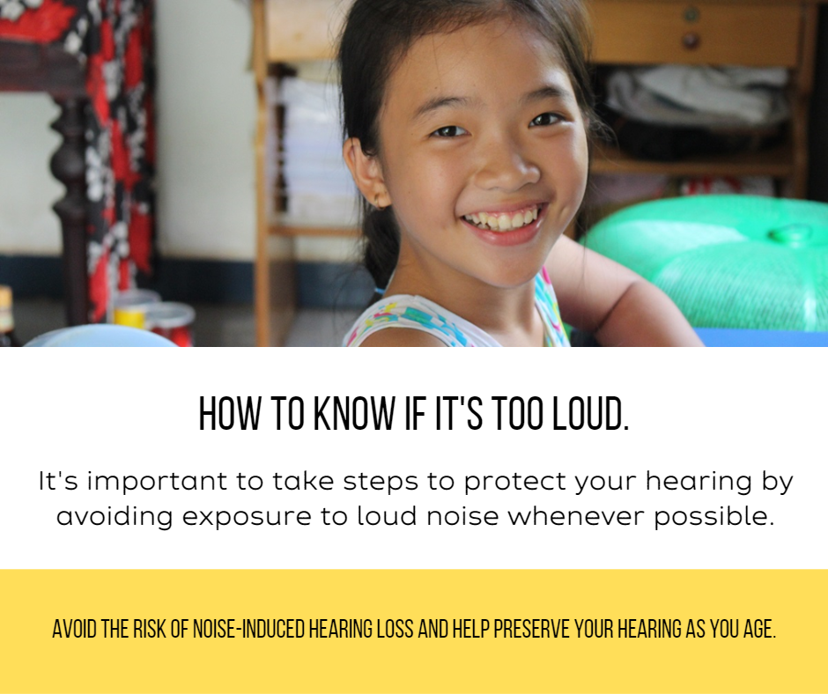

Throughout the world, nearly 50% of people aged 12–35 years of age – that’s 1.1 billion young people – are at risk of hearing loss due to prolonged exposure to loud sounds, through listening to music on smartphones and audio players, or at concerts and clubs.

Here in Australia, nearly 50% of young people are exposed to unsafe levels of sound from the use of personal audio devices.

Around 40% of 12–35 year-olds are exposed to damaging sound levels at clubs and bars.

Practising safe listening is one of the simplest ways to prevent hearing loss that is caused by recreational exposure to loud sounds.

#safelisteningweek
#safelistening

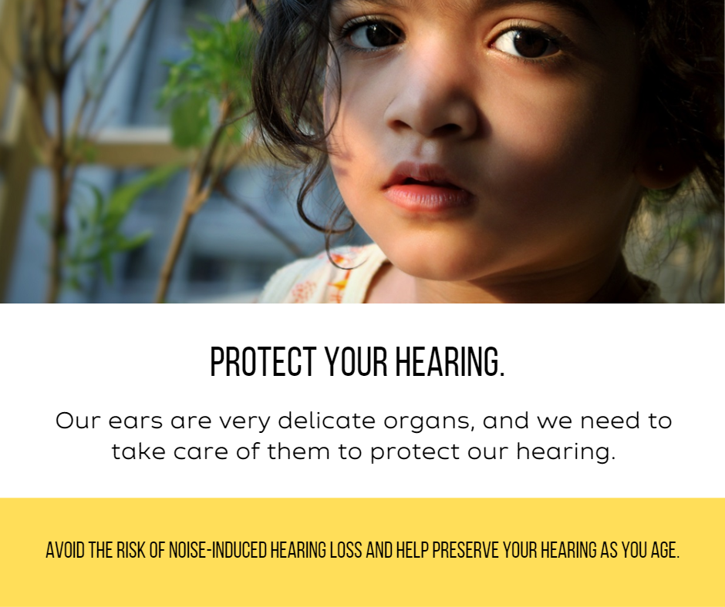

When hearing loss is ignored it can have a bad effect on many aspects of life.

It affects the way people connect and communicate.

Children with hearing loss may not get the best from their education if they don’t receive necessary supports.

Adults with hearing loss also have a much higher unemployment rate.

Lack of social engagement and loneliness, especially in older people, can further contribute to cognitive decline and depression.

So let's start taking care of our hearing.

#safelisteningweek
#safelistening

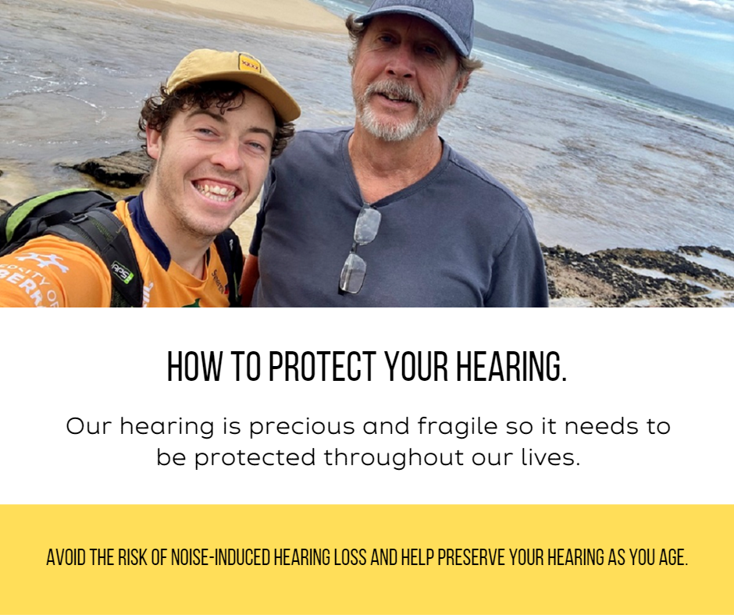

Australians with good hearing health are better able to lead fulfilling and productive lives.

Many people develop hearing loss from prolonged exposure to loud sounds. It can occur in workplace, environmental or recreational settings.

Safe listening practices can go a long way to protecting your hearing while you are enjoying your activity.

- Keep the volume down.
- Carry ear protection and use it when noise levels build.
- Limit time spent engaged in noisy activities.
- Be aware of dangerous noise levels.

Our hearing is fragile and precious. Protect your ears from loud sounds for better lifelong hearing.

#safelisteningweek
#safelistening

