Fact Sheet: Protect your Hearing with the Right Habits.

Our ears are very delicate organs, and we need to take care of them to protect our hearing.
Here are some healthy habits you can adopt to reduce your risk of hearing loss, whether you’re already experiencing hearing loss or not.

- Be mindful of the noise around you. Reduce your exposure to loud noise whenever possible.
- Wear hearing protection when you’re going to be exposed to loud sounds. Earmuffs and earplugs are both excellent options.
- Use earplugs when you’re going to be in noisy environments, such as at concerts or while mowing the lawn.
- Turn down the volume of your music, television, or other audio devices to a safe level.
- Give your ears a break every now and then. If you’re in a noisy environment, take a few minutes to step outside or go to a quieter room to rest your ears.
- Finally, take care of your overall health. Exercise, eat a balanced diet, and get enough sleep to help maintain healthy blood flow to your inner ear and protect your hearing.
By adopting safe listening habits, you can significantly reduce your risk of noise-induced hearing loss and help preserve your hearing as you age.

Fact Sheet: Understanding Noise-Induced Hearing Loss.
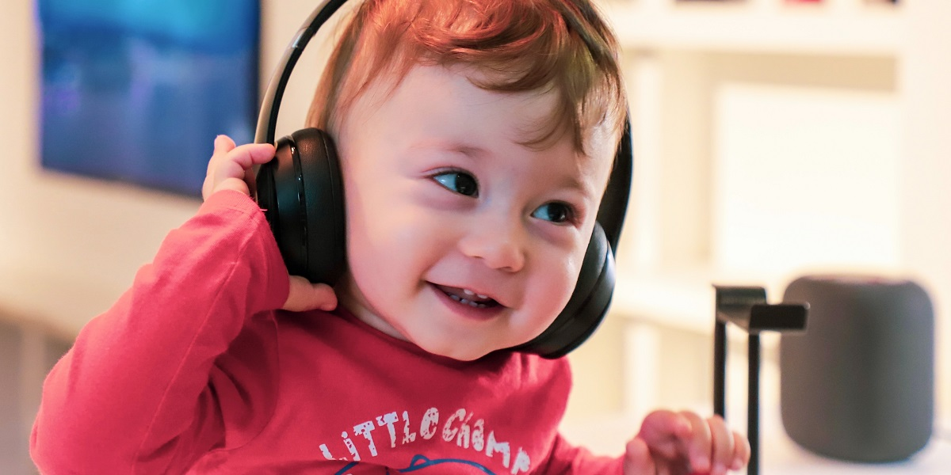
Noise-induced Hearing Loss is a type of hearing loss caused by exposure to loud sounds.
The damage caused by noise accumulates over time, and the more often you’re exposed to loud noise, the more damage your ears will sustain.

Here are some important things to understand.
- Noise-induced Hearing Loss can lead to communication difficulties, learning difficulties, pain or ringing in the ears (tinnitus), distorted or muffled hearing, and an inability to hear some environmental sounds and warning signals.
- Blasts like gunfire or fireworks can cause immediate hearing loss, while less explosive sounds like airplane engines or rock concerts can cause damage more slowly.
- Even if you're as healthy as an Olympian and eat salads all day long, you still risk hearing damage if you don't protect your hearing in noisy environments.
- Anything over 85 decibels can cause hearing loss, and the damage is almost always irreversible and cumulative.
By understanding the risks of noise-induced hearing loss, you can take steps to protect your hearing and prevent further damage.

Fact Sheet: Common sources of Noise-Induced Hearing Loss.
Prolonged or repeated exposure to loud sounds can lead to a gradual and irreversible loss of hearing. Here are some examples:

- Recreational activities: Attending loud concerts, using power tools, and loud vehicles can all lead to Noise-Induced Hearing Loss if adequate hearing protection is not used.
- Workplace noise: Many workplaces, particularly in manufacturing, construction, transportation and recreation, expose workers to high levels of noise on a regular basis.
- Personal listening devices: Listening to music or other audio through headphones or earbuds at high volumes can lead to Noise-Induced Hearing Loss over time. It's important to take breaks and keep the volume at a safe level.
- Household appliances: Vacuum cleaners, blenders, and hair dryers can produce noise levels that can cause hearing damage with repeated exposure.
- Environmental noise: Living in close proximity to busy roads, airports, or other sources of loud environmental noise can also contribute to Noise-Induced Hearing Loss over time.
Overall, it's important to be aware of the various sources of noise that can cause hearing damage and take steps to protect your ears from excessive noise exposure.

Fact Sheet: How to Know If It's Too Loud.
Exposure to loud noise can cause permanent hearing damage. Here are some tips to help you determine if the noise around you is too loud.

- If you need to shout to be heard by someone standing about an arm's length away, the noise is probably too loud.
- If you experience ringing in your ears or temporary hearing loss after being exposed to noise, it's a sign that the noise was too loud.
- If you have to raise your voice significantly to have a conversation with someone who is only a few feet away, the noise level is likely too loud.
- If you can't hear someone who is speaking to you from two feet away, the noise around you is probably too loud.
- If you need to turn up the volume on your TV or radio to hear it over the noise around you, it's a sign that the noise level is too high.
- If you are exposed to noise for a prolonged period of time, even if it doesn't seem too loud, it can still cause damage to your hearing.
It's important to take steps to protect your hearing by avoiding exposure to loud noise whenever possible, wearing earplugs or other protective gear in noisy environments, and turning down the volume on electronic devices.

Fact Sheet: How to Protect Your Hearing.
Our hearing is precious and fragile so it needs to be protected throughout our lives.
So, it is important to take care of your hearing to prevent hearing loss and related health problems.

- Wear earplugs or earmuffs when exposed to loud noises for extended periods of time.
- Take breaks from loud noises.
- Lower the volume on electronic devices such as headphones and speakers.
- Use noise-cancelling headphones or earbuds to reduce the need for higher volumes.
- Be mindful of noisy activities in your daily life, such as mowing the lawn or attending concerts.
- Keep a safe distance from sources of loud noises.
Simple steps such as wearing earplugs or earmuffs, taking listening breaks, and keeping the volume down on personal audio devices can go a long way in preserving your hearing.
Have your hearing tested regularly to monitor any changes and join a support group for individuals with hearing loss to connect with others who understand the challenges of living with hearing loss.
By having safe listening strategies, you can take an active role in protecting your hearing and ensure that you can continue to enjoy the sounds of life for years to come.

