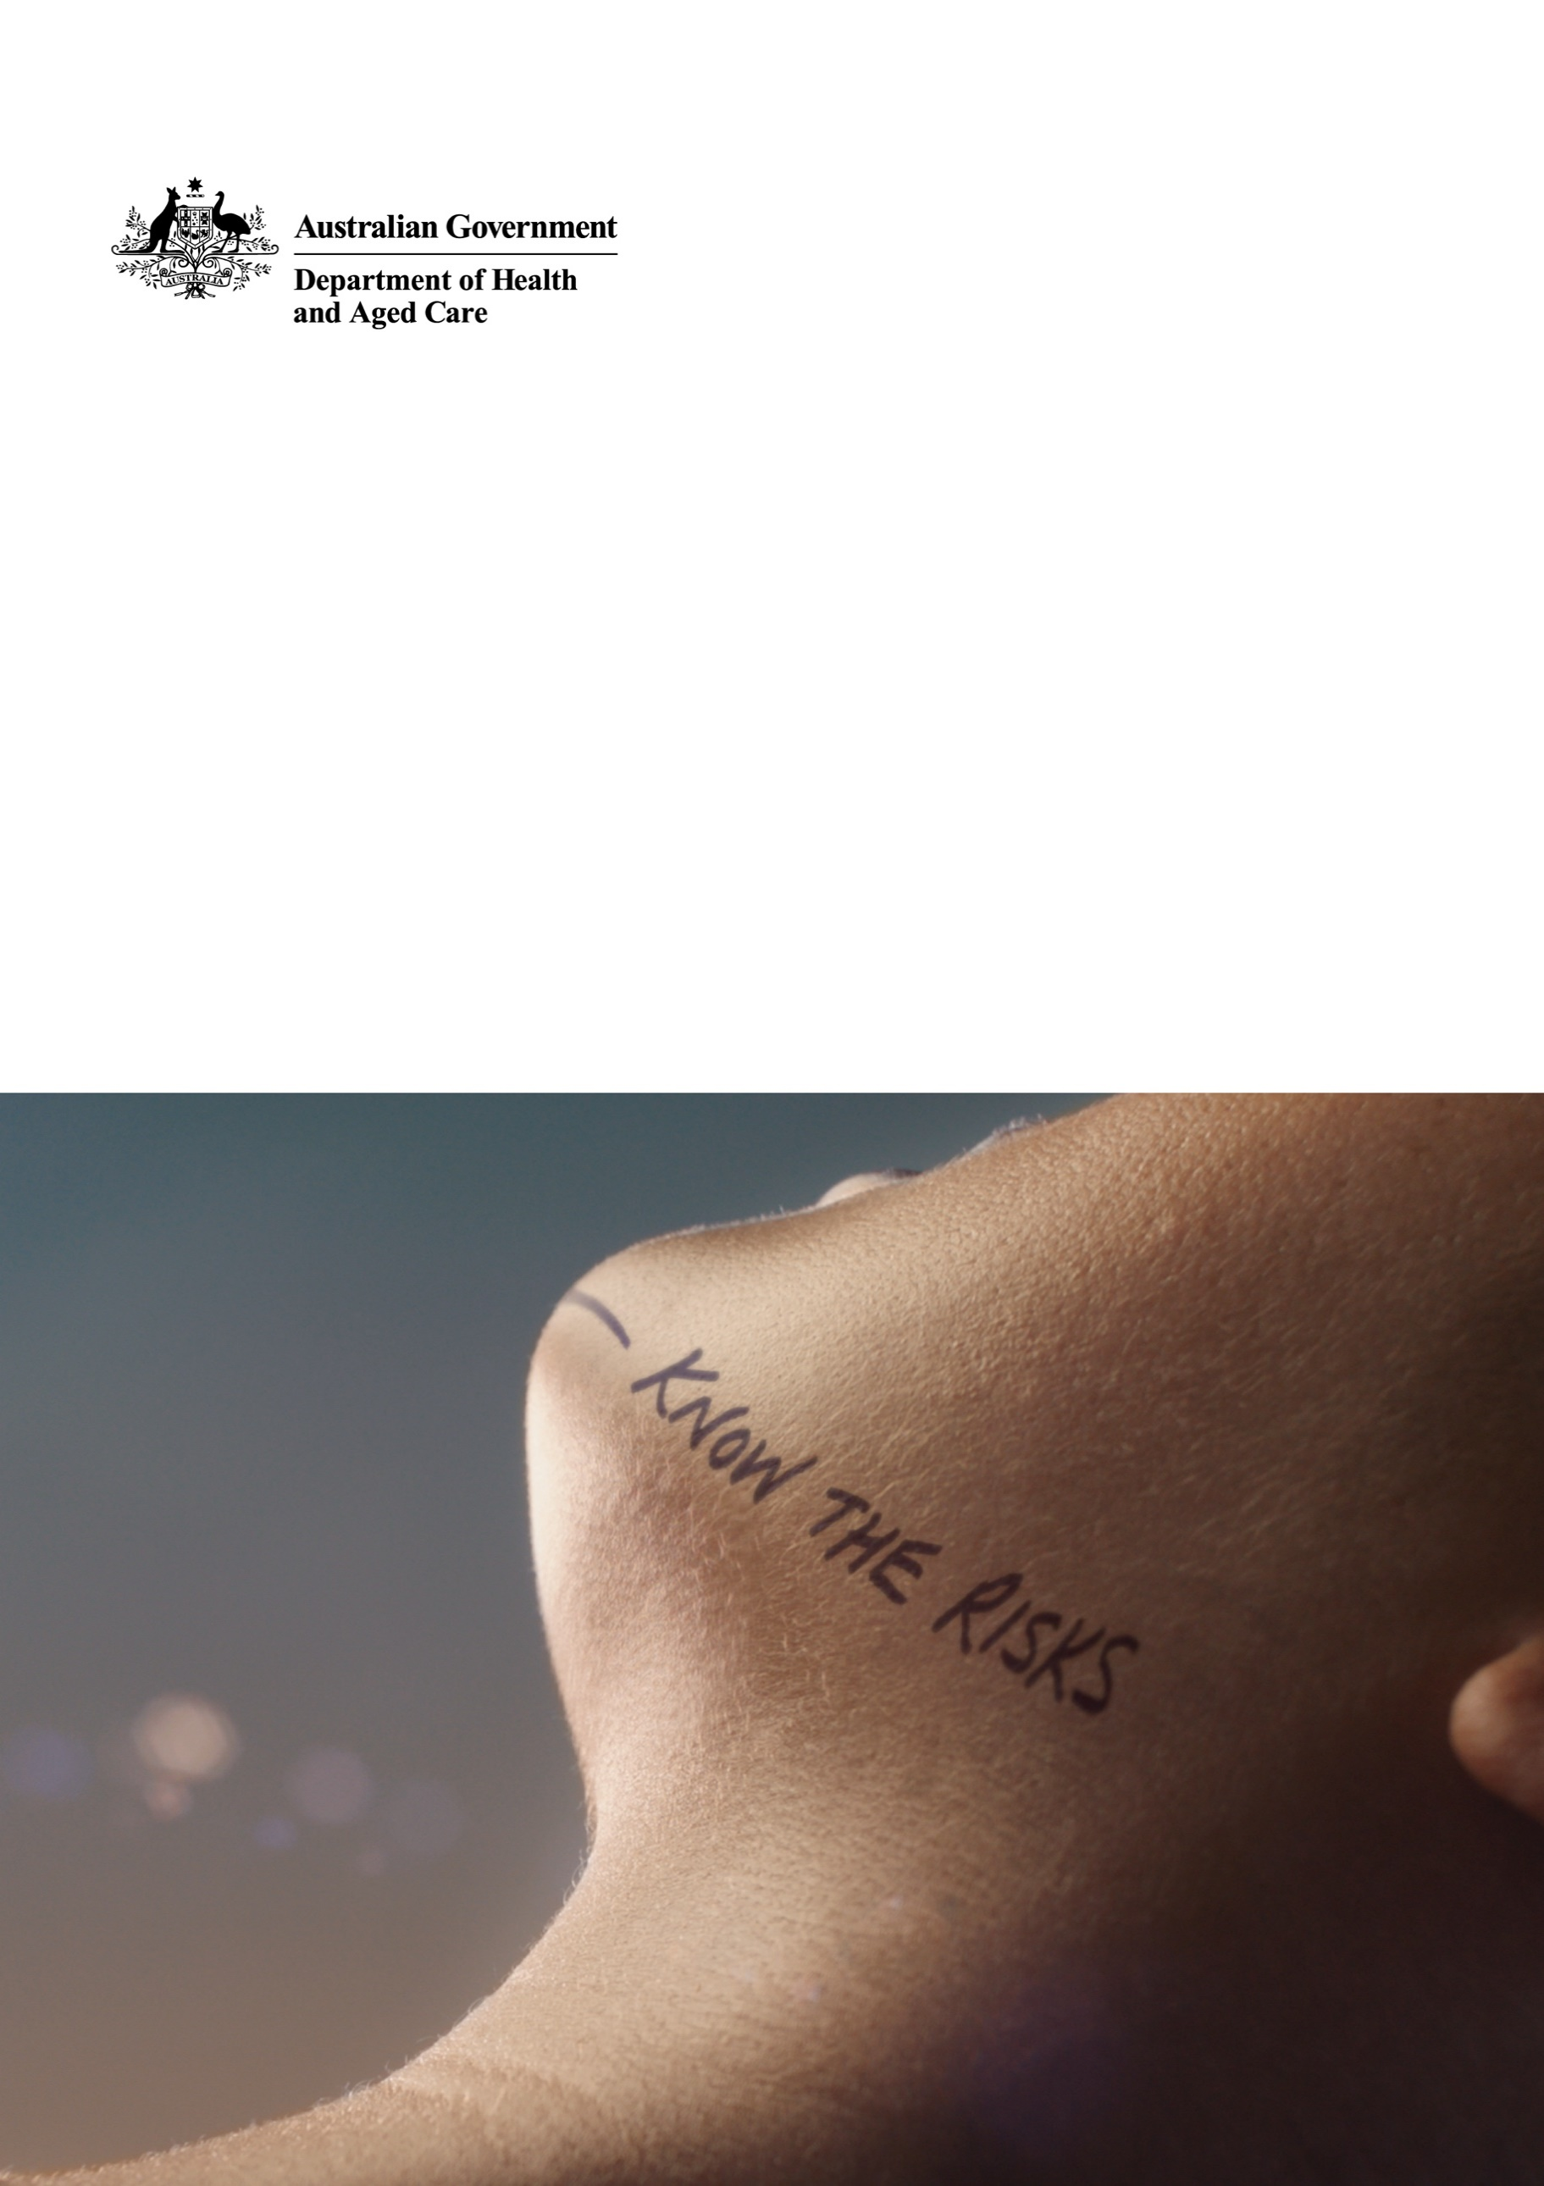

Get to know your local ear and hearing health professional

Communications Kit - Hearing Health Awareness and Prevention

June 2023



# Communication kit

This communication kit encourages people with untreated or developing hearing loss (primarily in the 50–70 year age group) to proactively manage their hearing health.

As an ear and hearing health specialist, you are an important part of communicating about hearing health to the community.

We encourage you to use the materials and resources to engage with your community on the importance of maintaining hearing health at all stages of life and the long-term benefits of routine preventative care.

This kit includes:

* Background
* Key messages
* Communication ideas
* Materials and resources
* Social media content
* Website/newsletter content
* Sample media release.

## How to use the kit and materials

The materials in this kit and the resources on the website are available for you to use in your own community. You may want to use them on your social media channels or print some of the information sheets for your clients.

There is some suggested content for social media and for your own newsletters and website. You may want to tailor this information for your own audience, while maintaining the overall key messages of hearing health and preventative care.

## Further information

Information about hearing health can be found at [health.gov.au/hearing](https://www.health.gov.au/hearing-health)

## Contact

Communication Campaigns Section  
Department of Health and Aged Care  
[campaigns@health.gov.au](mailto:campaigns@health.gov.au)

# Background

An estimated 3.6 million Australians experience some form of hearing impairment. As Australia’s population ages, this is estimated to double to 7.8 million people in 2060[1].

Untreated hearing loss can have a significant impact on everyday life.

Many Australians with hearing loss do not seek treatment. This is due to stigma, or lack of understanding about the long-term consequences of delaying treatment. Early awareness and intervention can help prevent further hearing loss.

This communication aims to increase awareness of why Australians should look after their hearing health, and what they can do to check their hearing and prevent or reduce hearing loss.

# Key messages

* It is important to think about hearing in the same way you think about other aspects of your health.
* You can get help for your hearing health.
* Having a hearing test helps to detect the early signs of hearing loss, so we can keep our hearing healthy for longer.
* Book a hearing check, talk to a health professional, or visit **health.gov.au/hearing** for more information.
* Most types of hearing loss are permanent. It’s important to take care of your hearing and prevent hearing loss before it occurs.
* If you know someone who may experience hearing loss, encourage them to get a hearing check.

# Communication ideas

On the next few pages, you will find a range of communication materials you can use to build awareness of hearing health and the benefits of routine preventative care.

There are many ways you can use these materials and build awareness within your networks. Here’s some ideas:

* Add your details to the editable poster and print and display in your community facing areas. If you have a contact at your local library or council, you could also ask to display these posters in community spaces, such as the library, community centre(s) or town hall.
* Research local community groups, such as the local RSL, Lions or Rotary Club and reach out to see if you can present at an upcoming meeting or event and/or display your poster.
  + Use the slides in this kit as a basis for your presentation.
* Find out if there any local events happening in your area, such as markets, concerts, seniors events/activities, where you could connect with potential clients. You could reach out to your local council to see if you can have a presence at one/some of these events.
  + Use the materials to complement your own collateral.
* Hold an Open Day where your community can find out more about your services and the importance of hearing health.
  + Use the materials to complement your own collateral. Use the sample media release as a basis and submit to the local paper to advertise your event.
* If you have a Facebook page, use the social media posts included in this kit as a basis for a post.
  + Use the social media tile provided to complement your post – people may have seen the videos and the recognisable imagery may help with cut through.
  + Tell client stories, with their permission, on social media.
* Use the suggested newsletter content and sample media release to draft an editorial piece on the importance of hearing health, which you could send to the local paper/bulletin.

# Materials and resources

The below materials can be downloaded from the ‘Resources’ page at [health.gov.au/hearing](https://www.health.gov.au/hearing-health).

|  |  |  |  |
| --- | --- | --- | --- |
| Resource title | Suggested use | Variations available | Preview |
| **30 second video** | Embed on your website and share on social media. | With and without captions and translated into seven languages* |  |
| **15 second video – birthday party** | Embed on your website and share on social media. | With and without captions and translated into seven languages* |  |
| **15 second video – cafe** | Embed on your website and share on social media. | With and without captions  and translated into seven languages* |  |
| **Social media infographics** | Share on your social media. | English and translated into seven languages* |  |
| **Animation: Managing your hearing**  1 minute 45 seconds | Embed on your website and share on social media. | English  With and without captions |  |
| **Animation: Protecting your hearing**  1 minute 46 seconds | Embed on your website and share on social media. | English  With and without captions |  |
| **Managing Hearing Loss**  **Information Sheet** | Promote across your channels. | English and translated into seven languages* |  |
| **Protecting Your Hearing**  **Information Sheet** | Promote through your channels/ networks. | English and translated into seven languages* |  |
| **Protecting Your Hearing at Work**  **Information Sheet** | Promote through your channels/ networks. | English |  |
| **Tips for Talking to People with Hearing Loss** | Promote across your channels. | English |  |
| **Tips for Communicating When You Have Hearing Loss** | Promote across your channels. | English |  |
| **Stay connected with family, friends, community and culture Information Sheet** | Promote through your channels/ networks. | English |  |
| **One in six Australians experience hearing loss poster** | Promote across your channels and facilities. | English and editable version |  |
| **Hearing well keeps you connected with family, friends, community & culture Poster** | Promote through your channels/ networks. | English |  |
| * Resource is available in Arabic, Cantonese, Korean, Mandarin, Punjabi, Vietnamese and Spanish. | | | |

# 

# Social media content

The content below can be used alongside the visual materials and published on your social channels.

| Channel | Copy |
| --- | --- |
| Facebook, Instagram & Twitter | One in 6 Australians have a hearing loss, but you can get help for your hearing health.  Having a hearing test helps to detect early signs of hearing loss, so we can keep our hearing healthy for longer.  Book a hearing check, talk to a health professional, or visit **health.gov.au/hearing** for information. |
| Facebook, Instagram & Twitter | Look after your hearing in the same way you look after other aspects of your health.  Having a hearing test helps to detect early signs of hearing loss, so we can keep our hearing healthy for longer.  Find out more at **health.gov.au/hearing** |
| Facebook, Instagram & Twitter | Untreated hearing loss can affect your mental and physical health and have a big impact on your life.  A hearing test can help to detect the early signs of hearing loss, so you can keep your hearing healthy for longer.  For information on looking after your hearing health and how to book a hearing test, visit **health.gov.au/hearing** |
| Recreational noise  Facebook & Instagram  Twitter | Most types of hearing loss are permanent. It’s important to take care of your hearing and prevent hearing loss before it occurs.   * Keep music and noise at a reasonable level – you should be able to easily understand someone talking to you from a metre away. * Keep the volume down in your headphones – it shouldn’t be loud enough for someone next to you to hear. * Wear ear plugs in clubs, at events and when undertaking noisy activities.   For more information on looking after your hearing, visit **health.gov.au/hearing**  -------------  Take care of your hearing and prevent hearing loss before it occurs. Keep music down and wear ear plugs in noisy environments. Visit **health.gov.au/hearing** for more information. |
| Friends and family of people with hearing loss  Facebook, Instagram & Twitter | One in 6 Australians have a hearing loss, but many people avoid or delay seeking treatment.  Hearing loss can have a big impact on a person’s life, but help is available.  If you know someone who may be experiencing hearing loss, encourage them to get a hearing check.  Find out more at **health.gov.au/hearing** |

The following hashtags are associated with this content:

* #hearing
* #hearinghealth
* #hearingtest

# Website/newsletter content

**Book your hearing check and hear all that life has to offer**

Hearing loss is common among Australians, with 1 in 6 people experiencing some form of difficulty hearing.

Left untreated, hearing loss can affect mental and physical health and have a big impact on everyday life.

That’s why it’s important to think about hearing in the same way you think about other aspects of your health.

Many Australians with hearing loss do not seek treatment—but help is available.

Having a hearing test can help to detect the early signs of hearing loss, so you can keep your hearing healthy for longer.

Hearing aids are not the only treatment for hearing loss. Following a hearing check, a range of management options may be discussed including communication strategies, assistive listening devices and phone apps.

If you are concerned about your hearing, or the hearing of someone you love, book a hearing check with you local hearing health professional today.

For more information visit **health.gov.au/hearing.**

**Sample media release**

<Insert date>

**<Suburb/area> residents urged to prioritise their hearing health**

An estimated 3.6 million Australians experience some form of hearing impairment, but for 1 in 3 of those, it could have been prevented.[2]

Audiologist/audiometrist <name>, wants <suburb/area> residents to think about hearing in the same way they think about other aspects of their health.

“Some people with hearing loss may delay or not seek treatment for a range of reasons, but untreated hearing loss can have a big impact on our lives,” <name> says.

Hearing loss can affect social and emotional wellbeing and can reduce a person’s ability to get an education or find work – but there are a range of options to help manage and treat hearing loss.

“Having a hearing test helps detect the early signs of hearing loss and can help keep your hearing healthy for longer,” <name> says.

“It’s an easy process, you don’t even need a referral.”

You can learn more about ways to prevent and treat hearing loss by <insert call to action, examples below>.

**Call to action examples *– for you to add as suitable for your community***

Coming along to <audiologist/audiometrist practice name>’s Open Day on <date, time>.

Visiting <audiologist/audiometrist practice name>’s website <website address>.

Visiting health.gov.au/hearing.

1. *Roadmap for Hearing Health Hearing Health Sector Committee Supporting all Australians who are deaf or hard of hearing to live well in the community Report*
2. *Roadmap for Hearing Health Hearing Health Sector Committee Supporting all Australians who are deaf or hard of hearing to live well in the community Report*