Social media posts – Get Help with Your Hearing.

The Australian Government has created a national awareness campaign to encourage people with untreated or developing hearing loss (aged 50–70 years) to proactively manage their hearing health. It is aimed at both individuals and family members. For more information visit our website.

Here are six social media posts that we hope you can use in your channels to support the campaign throughout 2023.

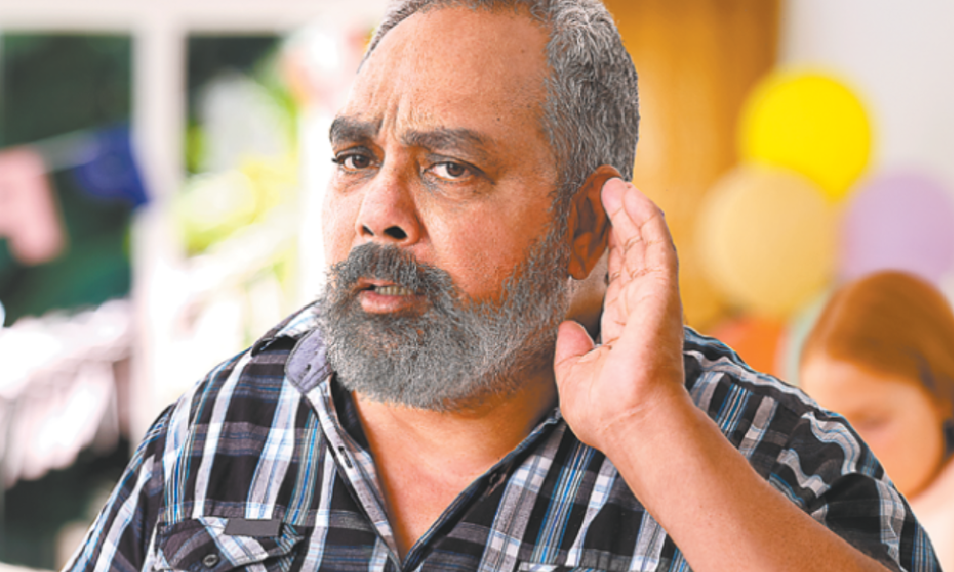

It is important to think about your Hearing in the same way you think about other health concerns.

Untreated hearing loss can have a big impact on your life.

Read about:

- Ways to prevent and manage hearing loss, https://www.health.gov.au/hearing-health/prevention-and-management

- Supporting people experiencing hearing loss, https://www.health.gov.au/hearing-health/supporting-others

Book a hearing check:
If you are concerned about your hearing or are experiencing hearing loss, a test by a hearing care professional can help determine the type of hearing loss and how much it has progressed.

Take this link, https://www.health.gov.au/hearing-health/book-a-hearing-check

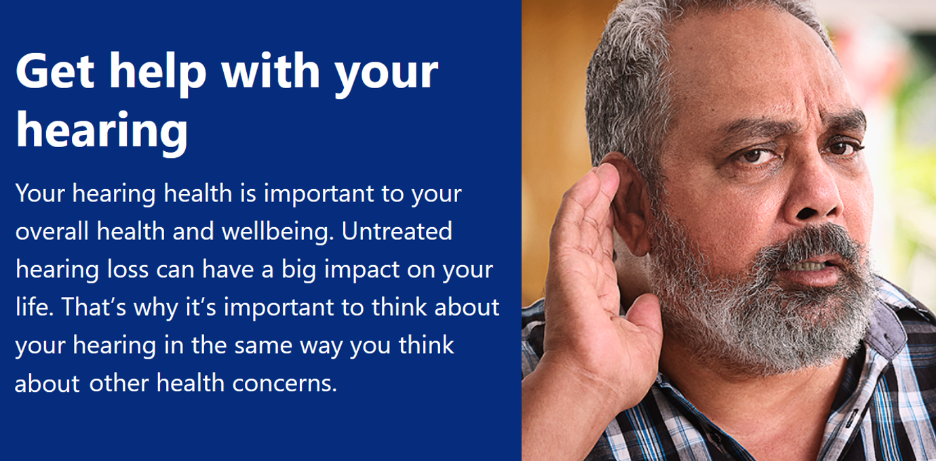

Your Hearing Health is important to your overall health and wellbeing.

Don’t ignore hearing problems because it can have a big impact on your life.

LEARN MORE:

- Fact sheets, posters, and videos about hearing health
- Information about managing hearing loss
- Tips for talking to people with hearing loss
- Tips for communicating when you have hearing loss
- Information for health care settings
- Infographics

Visit https://www.health.gov.au/hearing-health/resources

Hearing loss is common among Australians, with 1 in 6 people experiencing some form of difficulty with their hearing.

Get help for your hearing loss. https://www.youtube.com/watch?v=9QAqOx3hNz4&t=6s

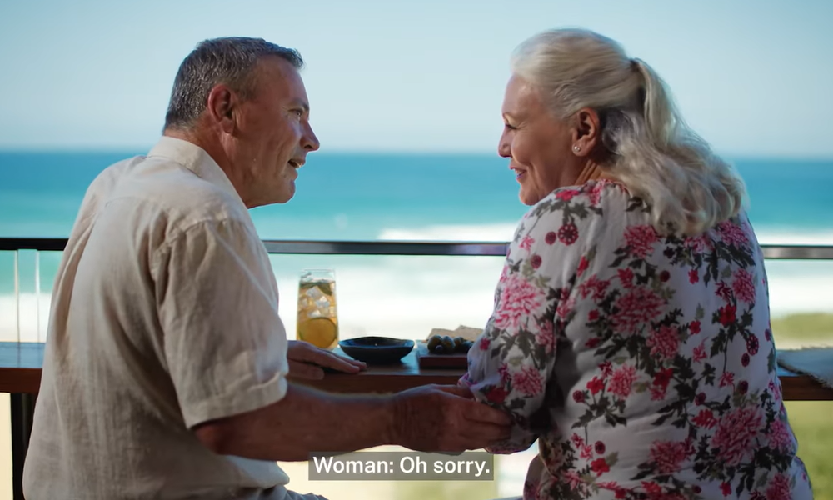

Having a hearing test can help to detect the early signs of hearing loss, so you can keep your hearing healthy for longer.

https://youtu.be/K9zDHgVi7HI

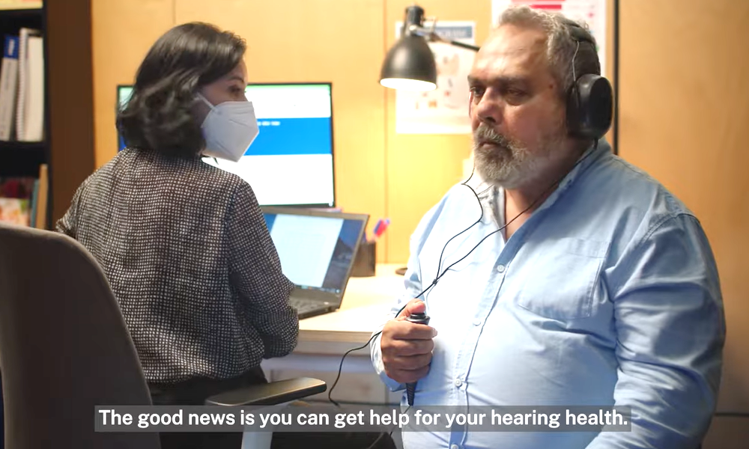

Get help for your hearing loss. Left untreated it can affect mental and physical health and have a big impact on everyday life.

https://www.youtube.com/watch?v=K9zDHgVi7HI

If you do nothing about it, hearing loss can affect your mental and physical health and have a big impact on everyday life.

Get help for your hearing loss. https://www.youtube.com/watch?v=9QAqOx3hNz4&t=6s

