4430.0 - Disability, Ageing and Carers, Australia: Summary of Findings, 2018

Disability
In 2018, 17.7% of all Australians had disability, down from 18.3% in 2015 and 18.5% in 2012. Prevalence was similar for males and females:
- 17.6% of males, down from 18.0% in 2015 and 18.0% in 2012
- 17.8% of females, down from 18.6% in 2015 and 19.0% in 2012.
The age standardised disability rate was 16.1%, down from 17.0% in 2015 and 17.4% in 2012.
Definitions:
Disability - any limitation, restriction or impairment which restricts everyday activities and has lasted, or is likely to last, for at least six months. For more information see the Explanatory notes.
Age standardisation - removes the effects of age allowing comparisons between two or more populations with different age structures. For more information see the Explanatory notes.
Number of people with disability
The number of people with disability has increased. In 2018, there were 4.4 million people with disability (up from 4.3 million in 2015). Of all people with disability, 1.9 million were aged 65 years and over (up from 1.8 million in 2015):
- representing almost half (44.5%) of all people with disability (up from 41.9% in 2015 and 40.7% in 2012); and
- reflecting both an ageing population and increasing life expectancy of Australians.
Age and sex
The rate of disability generally increased with age for males and females:
- 3.7% of 0-4 year olds had disability, increasing to 84.6% of those aged 90 years and over
- the largest difference between males and females was for children aged 5-14years (12.0% of boys with disability compared with 7.1% of girls).
Disability prevalence rates by age and sex, 2018
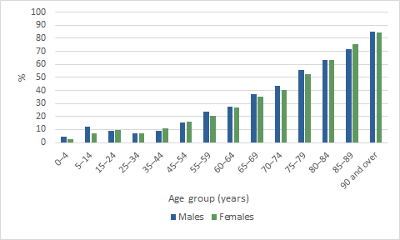
Source(s): ABS Survey of Disability, Ageing and Carers: Summary of Findings 2018
Disability prevalence over time
The pattern of disability prevalence across age was similar between 2015 and 2018, however there were some notable changes among certain age groups:
- one-quarter (26.9%) of people aged 60-64 years had disability, down from 31.5% in 2015
- one in ten (9.9%) people aged 35-44 years had disability, down from 12.1%
- one in five (20.5%) women aged 55-59 years had disability, down from 24.4%.
Disability prevalence rates by age – 2015, 2018
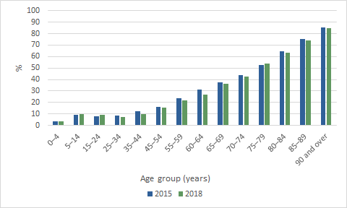
Source(s): ABS Survey of Disability, Ageing and Carers: Summary of Findings 2018
Disability status
Disability status is a measure of the severity of limitations experienced by people with disability. In 2018, of the 4.4 million Australians who had disability, almost 3.9 million people had a limitation with the core activities of communication, mobility or self-care and/or a schooling or employment restriction. As a proportion of the Australian population:
- 3.2% had a profound limitation
- 2.6% had a severe limitation
- 2.4% had a moderate limitation
- 6.1% had a mild limitation
- 1.4% had a schooling or employment restriction only.
These rates were similar to 2015.
Profound or severe disability by age and sex
Overall, females were more likely to have a profound or severe disability (6.0%) than males (5.5%); however, this was not the case for children. Generally, boys were more likely than girls to have a profound or severe limitation:
- 3.3% of boys aged 0-4 years, compared with 1.5% of girls
- 7.5% of boys aged 5-14 years, compared with 3.7% of girls.
This pattern was reversed for older people (older women were more likely than older men to have a profound or severe disability) reflecting, in part, the longer life expectancy of women:
- almost half (48.6%) of all women aged 85-89 years, compared with 35.6% of men of the same age
- over two-thirds (66.4%) of women aged 90 years and over, compared with 48.9% of men aged 90 years and over.
Disability prevalence rates by age and sex, 2018
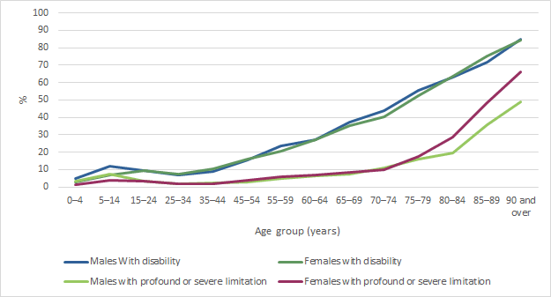
Source(s): ABS Survey of Disability, Ageing and Carers: Summary of Findings 2018
Definitions:
Profound limitation - greatest need for help, that is, always needs help with at least one core activity
Severe limitation - needs help sometimes or has difficulty with a core activity
Moderate limitation - no need for help but has difficulty
Mild limitation - no need for help and no difficulty, but uses aids or has limitations
Limitation - a person has a limitation if they have difficulty, need assistance from another person, or use an aid or other equipment to perform one or more core activities (communication, mobility and self-care). For more information see the Glossary.
Living arrangements
While most people (95.7%) with disability lived in households, 4.3% lived in cared-accommodation. The likelihood of a person with disability living in cared-accommodation increased with age and disability severity:
- one in five (19.4%) people with disability aged 80 years and over lived in cared-accommodation, compared with 3.2% of those aged 65-79 years
- less than 1.0% (13,500) of people aged 0-64 years with disability lived in cared-accommodation
- more than one in five (21.2%) people with a profound limitation lived in cared-accommodation, compared with 2.7% of those with a severe limitation.
Definitions:
Cared-accommodation - includes hospitals, nursing homes, aged care hostels, cared components of retirement villages, psychiatric institutions, and other 'homes' such as group homes for people with disability where a person must have been a resident, or expected to be a resident, for three months or more. For more information see the Glossary.
Disability prevalence in states and territories
Disability prevalence varied between Australia’s states and territories, due in part to their differing age structures. Most notably:
- over one-quarter (26.8%) of people in Tasmania had disability, higher than all other states and territories, followed by the Australian Capital Territory and South Australia (both 19.4%).

People with disability by state or territory of usual residence - 2018
 |  | All with reported disability
 |  |  |  | 2015 |  |  |  | 2018
State or territory of usual residence |  | '000 | % | RSE of  Estimate (%) |  | '000 | % | RSE of  Estimate (%)
 | New South Wales | 1372.4 | 18.1 | 2.3 |  | 1346.2 | 16.9 | 2.0
 | Victoria | 1098.8 | 18.5 | 2.1 |  | 1098.2 | 17.0 | 2.2
 | Queensland | 859.0 | 18.3 | 3.2 |  | 938.1 | 19.1 | 2.6
 | South Australia | 382.7 | 22.9 | 2.4 |  | 332.5 | 19.4 | 5.7
 | Western Australia | 362.7 | 14.6 | 3.1 |  | 411.5 | 16.4 | 2.5
 | Tasmania | 131.7 | 25.8 | 2.8 |  | 140.1 | 26.8 | 6.2
 | Northern Territory | 20.7 | 11.7 | 5.9 |  | 20.7 | 11.6 | 13.8
 | Australian Capital Territory | 62.0 | 16.2 | 3.4 |  | 80.0 | 19.4 | 6.1
Total |  | 4290.1 | 18.3 | 1.1 |  | 4367.2 | 17.7 | 1.2
Source(s): ABS Survey of Disability, Ageing and Carers: Summary of Findings 2018
There were some states and territories that experienced greater change in disability prevalence between 2015 and 2018:
- 19.4% of those in South Australia had disability, down from 22.9% in 2015
- 19.4% of those in the Australian Capital Territory had disability, up from 16.2% in 2015
- 16.4% of those in Western Australia had disability, up from 14.6% in 2015.
Main long-term health conditions of people with disability
Of the 4.4 million Australians with disability in 2018, over three-quarters (76.8%) reported a physical disorder as their main condition (the condition causing them the most problems), similar to 2015 (78.5%).
The most common physical disorder was a musculoskeletal disorder (29.6%, down from 31.4% in 2015), including:
- arthritis and related disorders (12.7%, no change from 12.7% in 2015)
- back problems (12.6%, down from 13.8% in 2015).
Of all people with disability, almost one-quarter (23.2%) reported a mental or behavioural disorder as their main condition, up from 21.5% in 2015. The most common mental and behavioural disorders were:
- psychoses and mood disorders (7.5%, similar to 7.6% in 2015),
- intellectual and development disorders (6.5%, similar to 6.3% in 2015)
- neurotic, stress related and somatoform disorders (6.1%) up from 5.2% in 2015.
Main long-term health condition by disability status
Those with a profound or severe limitation were more than twice as likely to report a mental or behavioural disorder (34.2%) than those with a moderate or mild limitation (14.5%).
Of those with a profound or severe limitation:
- 12.4% reported psychoses or mood affective disorders such as Dementia and Alzheimer's
- 12.1% reported intellectual or development disorders.
Those with a moderate or mild limitation were much more likely to report a physical condition (85.5%) than those with a profound or severe limitation (65.9%).
Of those with a moderate or mild limitation:
- 16.0% reported arthritis and related disorders
- 15.3% reported having back problems.
Definitions:
Long-term health condition - a disease or disorder that has lasted, or is likely to last, for six months or more. The SDAC collects information about long-term health conditions and through a series of screening questions, determines whether they restrict a person’s ability to do activities. People whose long-term conditions limit their activities are identified as having disability.
Main condition - for respondents with more than one long-term health condition, their main condition is the one causing the most problems.
Neurotic, stress-related and somatoform disorders – includes phobic anxiety disorders, other anxiety-related disorders, obsessive compulsive disorders, reaction to severe stress and adjustment disorders, dissociative (conversion) disorders, somatoform disorders and other neurotic disorders.
Employment characteristics of people with disability
Labour force participation
Labour force participation for people with disability has remained stable since 2015, in contrast to an increase in the participation rate for people without disability.
In 2018, 2.1 million people with disability living in households were of working age (15-64 years). Of these:
- over half (53.4%) were in the labour force, compared with 84.1% of those without disability
- almost half (47.8%) were employed, compared with 80.3% of people without disability
- 46.6% were not in the labour force, compared with 15.9% of those without disability.
Labour force participation by sex
Labour force participation was higher among men with disability than women with disability:
- 56.1% of men with disability compared with 50.7% of women with disability
- 31.0% of men with a profound or severe limitation compared with 23.6% of women with a profound or severe limitation.

Labour force participation by disability status
Labour force participation declined with the severity of limitation:
- 59.3% of those with a mild limitation
- 45.6% of those with a moderate limitation
- 27.2% of those with a profound or severe limitation.
Unemployment
The unemployment rate for people with disability has remained stable since 2015, in contrast to a decrease in the unemployment rate for people without disability (5.3% in 2015 to 4.6% in 2018). In 2018 the unemployment rate was:
- 10.3% for people with any type of disability (more than twice the rate for people without disability, 4.6%)
- 12.7% for people with a profound or severe limitation
- 11.8% for people with a moderate limitation
- 9.6% for people with a mild limitation.
Working full-time
In 2018, just over one-quarter (28.3%) of all people with disability of working age were employed full-time (similar to 2015), compared with more than half (54.8%) of those without disability (also similar to 2015). However, a higher proportion of people with a profound or severe disability were working full-time in 2018:
- 11.4%, compared with 7.9% in 2015, driven by an increase in women with a profound or severe disability working full-time (9.2% in 2018, up from 5.5% in 2015)
- 14.6% of men with a profound or severe disability worked full-time, though there was no statistically significant difference from 2015 (10.0%).
Employment restrictions
People with disability may experience employment restrictions because of their disability (such as restrictions around the type of job or number of hours they can work or a need for special equipment). In 2018, the following groups with disability had an employment restriction:
- almost half (47.8%) of those working full-time
- two-thirds (64.5%) of those working part-time
- almost three-quarters (73.7%) of those who were unemployed
- the majority of those not in the labour force (771,300 or 80.5%); and of these, 515,200 were permanently unable to work.
Definitions:
Employment characteristics – all data in this section refers to people with disability aged 15-64 years, living in households.
Labour force participation - refers to people who were employed or unemployed.
Unemployment rate - the number of unemployed people of any group as a proportion of the labour force in the same group.
Education
There have been some increases in education attainment for people with disability. In 2018, among all people with disability aged 15 years and over (living in households):
- one-third (33.4%) had completed year 12 or equivalent, up from 31.4% in 2015
- one in six (16.1%) had a Bachelor degree or above, up from 14.9% in 2015
- 9.2% had an advanced diploma or diploma, up from 8.2% in 2015.
Persons aged 15 years and over with disability(a), level of highest non-school qualification(b), 2015, 2018
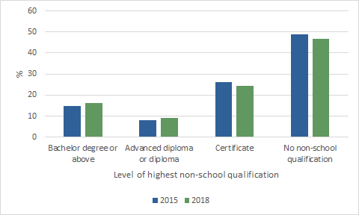
Footnote(s):
(a) Living in households
(b) Excludes those for whom highest level of non-school qualification was not determined
Source(s): ABS Survey of Disability, Ageing and Carers: Summary of Findings 2018
Income
Disability can affect a person’s capacity to work and earn an income. The following results relate to people of working age (15-64 years) who were living in households.
Personal income
In 2018, the median gross personal income of people with disability was $505 per week, less than half (49.7%) that of people without disability ($1016 per week). In 2015, the median gross personal income of people with disability was $465 per week, less than half (48.9%) that of people without disability ($950 per week).
Household income
People with disability were more likely to live in households with a lower equivalised gross household income compared with people without disability. Among those whose household income was known:
- half (50.2%) lived in a household in the lowest two quintiles, more than twice that of people without disability (24.0%)
- 13.5% lived in a household in the highest quintile, compared with 26.5% of people without disability.

Persons aged 15-64 years(a), equivalised gross household income quintiles(b), by disability status, 2018
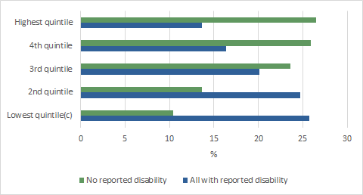
Footnote(s):
(a) Living in households
(b) Excludes people whose household income was not known
(c) Includes households with nil income and households who reported no source of income
Source(s): ABS Survey of Disability, Ageing and Carers: Summary of Findings 2018
Definitions:
Equivalised gross household income - adjusts actual income to take into account the different needs of households of different size and composition. For more information see the Glossary.
Main source of income
In 2018, the most common main sources of income for people with disability were:
- government pension or allowance (37.9%, down from 41.9% in 2015)
- wages or salary (37.6%), no significant change from 2015 (36.5%).
In 2018, a government pension or allowance was the main source of income for:
- over half (58.6%) of people with a profound or severe limitation, down from 68.5% in 2015
- over one-third (37.2%) of people with a moderate or mild limitation, similar to 2015 (40.7%).
Persons with a profound or severe limitation(a) aged 15-64 years, main source of income(b), 2015, 2018
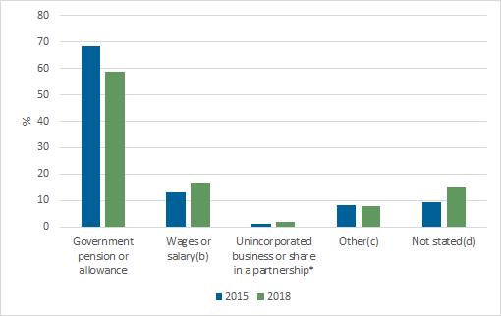
* Estimate has a high margin of error and should be used with caution.
Footnote(s):
(a) Living in households
(b) Including from own incorporated business
(c) Includes child support or maintenance, workers' compensation, profit or loss from rental property, dividends or interest, superannuation or annuity
(d) Includes persons who reported no source of income, or main source of income was not known.
Source(s): ABS Survey of Disability, Ageing and Carers: Summary of Findings 2018
Need for assistance
In 2018, of the 4.2 million Australians with disability (living in households), three in five (59.8% or 2.5 million people) needed assistance with at least one activity of daily life.
Assistance was most commonly needed with:
- health care (29.9%)
- property maintenance (27.1%)
- cognitive and emotional tasks (23.7%).
Persons with disability(a), activities for which assistance needed, 2018
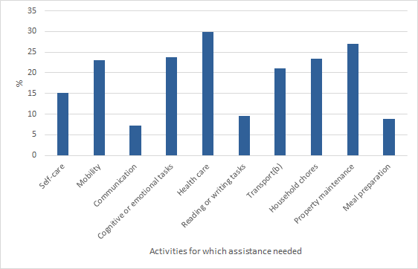
Footnote(s):
(a) Living in households
(b) Excludes public transport
Source(s): ABS Survey of Disability, Ageing and Carers: Summary of Findings 2018
Assistance needs for people with a profound limitation
Among people with disability (living in households) with a profound limitation (613,100 people), the greatest need for assistance was with:
- mobility (87.1%)
- health care (73.0%)
- self-care (65.9%).
Whether need for assistance was met
A person who needs assistance with an activity may or may not receive the help they require. Of the 2.5 million Australians with disability (living in households) who needed assistance:
- most (92.7%) received some help (formal and/or informal) with at least one of the activities they needed assistance with
- 59.7% had their needs fully met, down from 62.1% in 2015
- 37.7% had their needs partly met, up from 35.3% in 2015
- 2.7% did not have their needs for assistance met at all (the same as in 2015).
Less than half (48.1%) of those with a profound limitation had their needs fully met, compared with 68.4% of people with a mild limitation.
Assistance received by age
Among certain age groups there has been an increase in the proportion of people with disability whose assistance needs for certain activities were not fully met:
- one in eight (13.1%) people aged 0-64 years did not have their need for assistance with cognitive and emotional tasks met, up from 10.9% in 2015
- 7.1% of people aged 65 years and over did not have their need for assistance with household chores met, up from 5.9% in 2015.
Persons with disability(a) who needed assistance, activities for which need for assistance not fully met(b) by age group, 2018
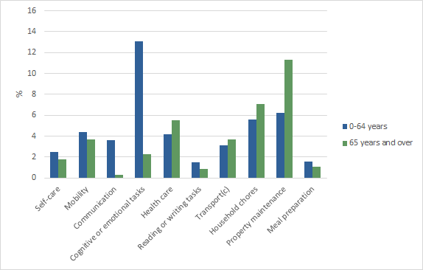
Footnote(s):
(a) Living in households
(b) Applies only to persons where need for assistance partly met or not met at all. A person's needs may not be fully met for more than one activity
(c) Excludes public transport
Source(s): ABS Survey of Disability, Ageing and Carers: Summary of Findings 2018
Service use
People with disability may be supported by formal and/or informal providers of assistance including government or private organisations, as well as family and friends. They may seek assistance from different providers for their various care needs.
Assistance from informal providers
In 2018, of the 2.5 million people with disability (living in households) who needed assistance, 79.1% received assistance from informal providers. Of those receiving informal assistance:
- two in five (40.5%) received assistance from a partner, down from 44.2% in 2015
- over one-quarter (27.3%) received assistance from their child, similar to 2015 (29.3%)
- over one-quarter (27.0%) received assistance from their parent, up from 24.4% in 2015.
Activities for which informal assistance was received
People with disability (living in households) needing assistance were most likely to receive informal assistance with:
- communication (88.1% of those needing help with this activity received informal help with this task)
- mobility (84.8% of those needing help with this activity received informal help with this task)
- reading or writing tasks (84.8% those needing help with this activity received informal help with this task).
Frequency of informal assistance
Information about the frequency of informal care being provided helps our understanding of the extent to which people with disability rely on this informal assistance and can help with future service planning and carer supports. Among those who received informal assistance:
- just over half (53.2%) received daily assistance
- just over one quarter (27.2%) received assistance weekly.
Assistance from formal providers
Of the 2.5 million people with disability (living in households) who needed assistance, 58.0% received assistance from formal providers (such as private commercial organisations and government providers).
Activities for which formal assistance was received
People with disability (living in households) needing assistance were most likely to receive formal assistance with:
- health care (54.5% of those needing help with this activity received formal assistance with this task)
- cognitive and emotional tasks (49.9% of those needing help with this activity received formal assistance with this task)
- communication (42.5% of those needing help with this activity received formal help with this task).
Frequency of formal assistance
Among those who received formal assistance:
- two in five (40.9%) received formal help monthly
- over one-quarter (28.2%) received weekly formal assistance
- 17.9% received formal assistance on a yearly basis.
Comparison of informal and formal assistance
Of the 2.5 million people with disability (living in households) who needed assistance, the proportion who received assistance, and whether that assistance was formal or informal, varied across activities. The following graph provides a comparison of the different activities for which formal and informal assistance were most commonly received by those who needed it.

Persons with disability(a) who needed assistance with specific activities, assistance received by provider type, 2018
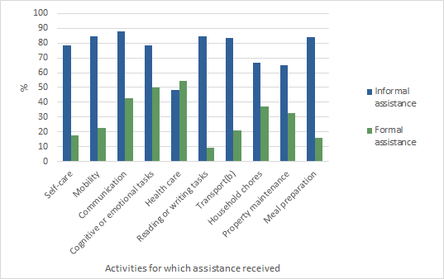
Footnote(s):
(a) Living in households
(b) Excludes public transport
Source(s): ABS Survey of Disability, Ageing and Carers: Summary of Findings 2018
Definitions:
Informal assistance - refers to unpaid help or supervision provided by family, friends and neighbours and only includes help provided because of a person’s disability.
Formal assistance - refers to paid care provided by organisations or individuals. For more information on formal and informal assistance see the Glossary.
Satisfaction with formal assistance
People aged 15 years and over who received formal assistance in the 6 months prior to the survey were asked how satisfied they were with both the quality of service and the range of services available.
Satisfaction with quality of service
In 2018, among those who received formal assistance with at least one activity, people aged 15-64 years were less likely to be satisfied with the quality of service (59.2%) compared with those aged 65 years and over (72.8%).
Satisfaction varied depending on the type of activity for which the assistance was received as well as by age.
Persons with disability(a) who received formal assistance(b), proportion satisfied with formal services received, by age group, 2018
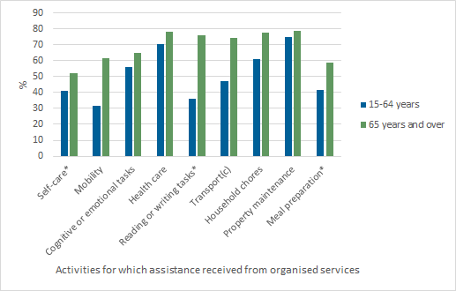
* Estimate has a high margin of error and should be used with caution.
Footnote(s):
(a) Living in households
(b) Received assistance from an organised service in the previous 6 months
(c) Excludes public transport
Source(s): ABS Survey of Disability, Ageing and Carers: Summary of Findings 2018
Satisfaction with range of services
Among those who needed formal assistance with at least one activity:
- 44.9% of people aged 15-64 years were satisfied with the range of services available compared with 61.2% of those aged 65 years and over
- regardless of age, people were most satisfied with the range of health care services available (58.3% of 15-64 year olds and 72.1% of people aged 65 years and over).
Aids and equipment
Aids used
People with disability may use aids or equipment to assist with their functioning, improve their independence and increase their participation in social and economic life. In 2018, of the 4.4 million Australians with disability, over half (53.1% or 2.3 million) used aids or equipment because of their condition. Use of aids varied according to a person’s living arrangements. Amongst all those with disability:
- 58.3% of those who lived alone used aids
- 49.3% of those who lived with others used aids
- 94.8% of those who lived in cared-accommodation used aids.
People with disability may use a variety of aids or equipment depending on personal and environmental factors, level of impairment or activity limitation, accessibility and affordability. In 2018:
- 29.4% of people with disability used communication aids, with 18.4% using a hearing aid
- 17.1% used aids for mobility tasks.
For certain activities, people who lived alone were almost twice as likely to use aids or equipment:
- 19.3% used aids or equipment for self-care, compared with 11.3% of those who lived with others
- 20.9% used aids for mobility tasks, compared with 12.3% of those who lived with others.
Persons with disability, activities for which selected aids or equipment used, by living arrangement, 2018
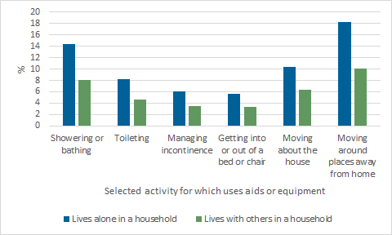
Source(s): ABS Survey of Disability, Ageing and Carers: Summary of Findings 2018
Modifications
Of the 4.2 million people with disability living in households, 12.2% (or 511,400) had made home modifications:
- 8.1% had handgrab rails
- 5.8% had bathroom, toilet or laundry modifications
- 2.6% had ramps installed.
Social and community participation
Participating in community activities can contribute to a person’s sense of wellbeing and help build social support networks.
In 2018, of the 4.1 million people aged 5 years and over with disability (living in households) three-quarters (76.2%) had participated in social activities away from home in the previous 12 months. Overall, participation in social activities away from home decreased with age. In the previous 12 months:
- nine out of ten (89.8%) children (aged 5-14 years) with disability participated in social activities
- eight in ten (80.8%) people aged 15-64 years with disability participated in social activities
- just over two thirds (68.5%) of people aged 65 years and over with disability participated in social activities.
When looking at social and community participation in the previous three months, the most commonly reported activities across all ages and disability levels were:
- visiting or going out with family and friends
- participating in physical activity for exercise or recreation.
Definitions:
Social and community participation data – includes data about people living in households aged 5 years and over who participated in one or more activities away from home in the 12 months prior to the 2018 survey.
Persons with disability(a) who participated in social activities away from home(b), types of social activities by age group, 2018
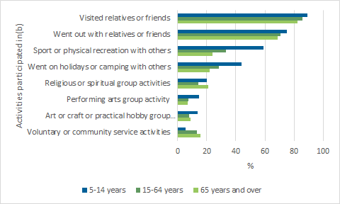
Footnote(s):
(a) Living in households
(b)Participated in social activities away from home in the previous 3 months
Source(s): ABS Survey of Disability, Ageing and Carers: Summary of Findings 2018
Access to public transport
Public transport can play a critical role in social and economic life, but may be difficult for those with disability. Of the 4.1 million people aged 5 years and over with disability (living in households):
- 40.9% used public transport
- over three-quarters (78.4%) could use all forms of public transport, most with no difficulty (65.6%)
- 6.3% could use some but not all forms of public transport
- one in seven (14.3%) could not use any form of public transport.
The more severe a person’s disability, the less likely they were to be able to use public transport:
- one in five (20.7%) people with a profound limitation used public transport, compared with 43.7% of those with a mild limitation
- almost half (47.0%) of people with a profound limitation could not use public transport at all, compared with 8.9% of those with a mild limitation.

Difficulty or inability to use public transport
Among people who reported a difficulty or inability to use public transport due to their condition, the most common reasons reported were:
- issues getting in or out of the vehicle because of steps (42.4%)
- getting to stops or stations (30.6%)
- fear or anxiety (23.0%)
- lack of seating or difficulty standing (21.3%).
Definitions:
Transport data – includes data about people aged 5 years and over living in households, excluding those who did not leave their home.
Disability discrimination
Disability discrimination occurs when people with disability are treated less fairly than others because of their disability. Among people with disability aged 15 years and over (living in households):
- one in ten (9.6%) had experienced discrimination, up from 8.6% in 2015
- one in ten (10.3%) women experienced discrimination, up from 8.9% in 2015
- one in eleven (8.8%) men experienced discrimination, similar to 2015 (8.3%)
- almost one in five young people aged 15-24 years (18.9%) and 25-34 years (18.2%) experienced discrimination, compared with 3.2% of those aged 65 years and over.
There have been statistically significant increases in the experience of discrimination among some age groups:
- around one in eight (12.9%) people aged 55-64 years, up from 9.4% in 2015
- 3.2% of people aged 65 years and over, up from 2.1% in 2015.
Persons with disability(a), proportion who experienced discrimination(b) by age group, 2018
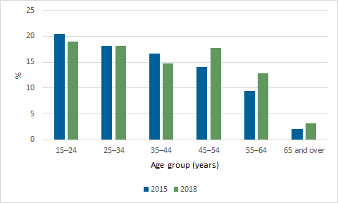
Footnote(s):
(a) Aged 15 years and over, living in households who had a personal interview
(b)Experienced discrimination in the previous 12 months
Source(s): ABS Survey of Disability, Ageing and Carers: Summary of Findings 2018
Experience of discrimination varied by severity of limitation:
- almost one in five (18.0%) people with a profound or severe limitation experienced discrimination, up from 12.7% in 2015
- 7.8% of people with a moderate or mild limitation experienced discrimination, similar to 2015 (7.6%).
Source of disability discrimination
Of those with disability who experienced discrimination, the most common sources of discrimination were:
- service and hospitality staff (36.3%)
- family and friends (21.0%)
- their employer (20.7%).
These rates were similar to 2015.
Disability discrimination in the labour force
Of those with disability in the labour force (aged 15-64 years) who had experienced discrimination, the most common sources of discrimination were:
- their employer (40.4%)
- work colleagues (34.5%).
Avoiding situations because of disability
In 2018, of the 3.3 million people with disability aged 15 years and over (living in households) almost one-third (33.1%) avoided situations because of their disability in the previous 12 months:
- three in ten (30.8%) men, increasing from 28.1% in 2015
- over one-third (35.3%) of women, the same as in 2015
- over half (51.0%) of people aged 15-24 years, compared with 21.2% of people 65 years and over
- over half (52.4%) of people with a profound or severe limitation, compared with 28.1% of those with a moderate or mild limitation
- two-thirds (67.0%) of people with psychosocial disability, higher than any other disability group.
Persons with disability(a), proportion who avoided situations, by disability group(b), 2018
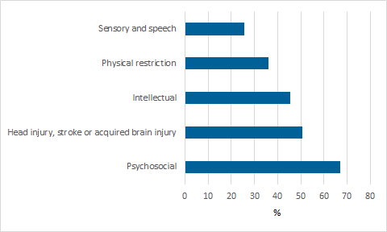
Footnote(s):
(a) Aged 15 years and over, living in households who had a personal interview
(b) Persons may have more than one disability therefore be included in more than one disability grouping
Source(s): ABS Survey of Disability, Ageing and Carers: Summary of Findings 2018
Situations avoided
Of those with disability who avoided situations because of their disability, the most common situations avoided were:
- visiting family and friends (39.2%)
- going to shops, banks etc. (34.3%)
- visiting restaurants, cafes or bars (31.8%).
Persons who avoided situations because of disability(a), types of situations avoided(b), by sex, 2018
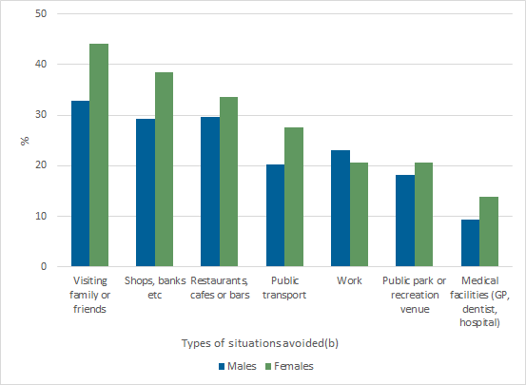
Footnote(s):
(a) Aged 15 years and over, living in households who had a personal interview
(b) Situations avoided due to disability in the last 12 months
Source(s): ABS Survey of Disability, Ageing and Carers: Summary of Findings 2018
Definitions:
Discrimination - refers to unfair treatment received because of disability in the previous 12 months.
Discrimination data – includes data about people with disability aged 15 years and over living in households who had a personal interview.
Service and hospitality staff - includes teacher or lecturer; health staff; bus drivers, retail staff or taxi drivers; restaurant or hospitality staff; or sales assistants.

